CONFIDENTIAL CS/OCT 2026/MAT133

UNIVERSITI TEKNOLOGI MARA FINAL EXAMINATION

COURSE
COURSE CODE
EXAMINATION TIME
PRE CALCULUS
MAT133 OCTOBER 2026
2 HOURS

INSTRUCTIONS TO CANDIDATES

- This question paper consists of 5 questions.

- Answer ALL questions in the Answer Booklet. Start each answer on a new page.

- Do not bring any material into the examination room unless permission is given by the invigilator .
- Please check to make sure that this examination pack consists of: i) the Question Paper
  - a one - page Append ix 1
  - an Answer Booklet - provided by the Faculty
  - a graph paper - provided by the Faculty

- Answer ALL questions in English.

/

DO NOT TURN THIS PAGE UNTIL YOU ARE TOLD TO DO SO

This examination paper consists of 8 printed pages

QUESTION 1
a) Write the solution of -x - 1 > -3 in interval notation and on a number line.
(3 marks)
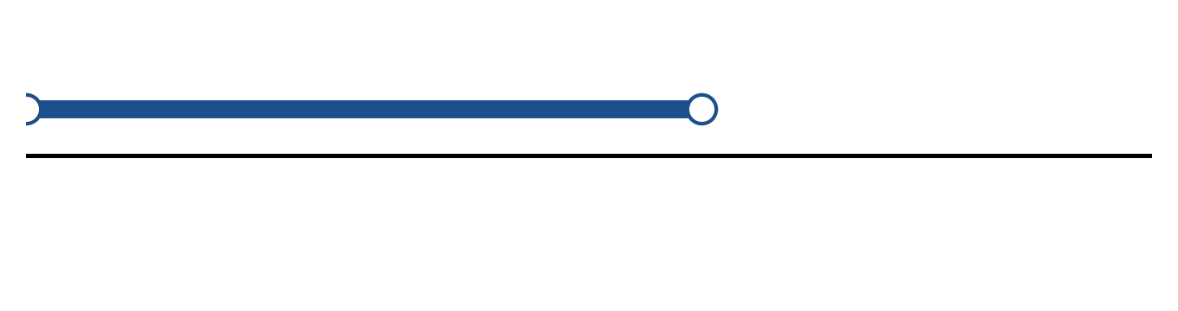
Figure: solution set.
b) Solve the inequality |-4x - 2| ≥ 3. Express the answer in interval notation and on a number line.
(5 marks)
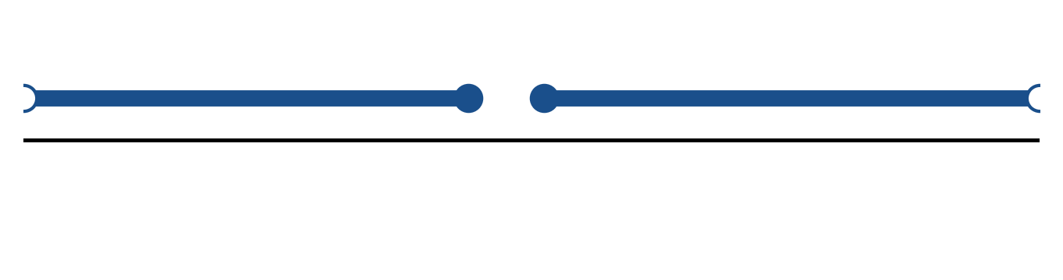
Figure: solution on a number line.
c) Solve the equation |2 - 5x| = 9.
(4 marks)
QUESTION 2
a) Given f(x) = x + 1 and g(x) = -x - 4, find (f + g)(x), (f - g)(x) and (f g)(x). State the domain of each.
(4 marks)
b) The piecewise function is defined by
f(x) = 3x + 4, if x < -1;
f(x) = -1, if -1 ≤ x ≤ 2;
f(x) = x² + 3, if x > 2.
Sketch the graph and find f(-2), f(0) and f(3).
(5 marks)
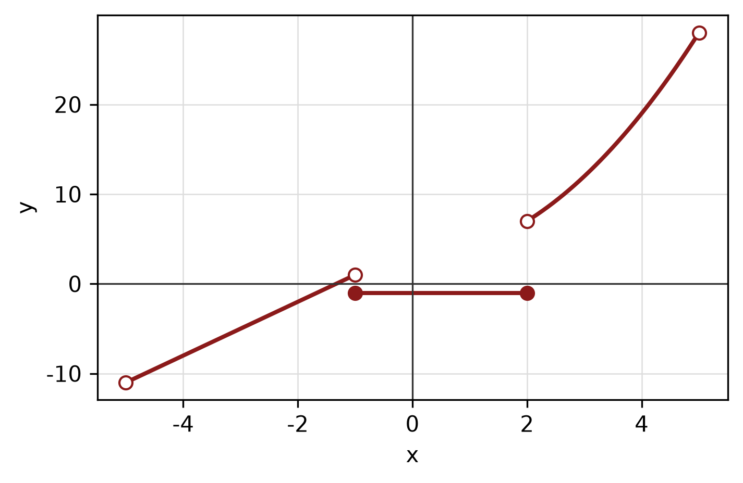
Figure: piecewise graph.
c) Write x² - 8x + y² + 8y + 7 = 0 in standard form. Hence state the centre and radius and sketch the circle.
(5 marks)
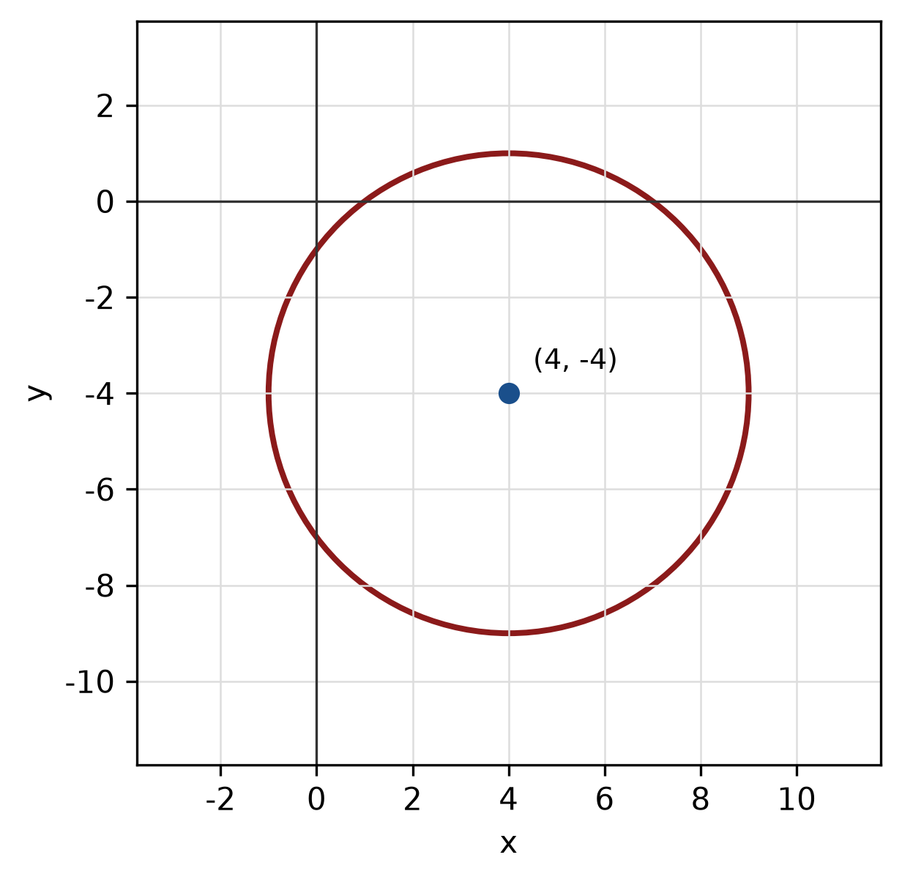
Figure: circle.
QUESTION 3
a) Given z₁ = -5 - 6i and z₂ = 4 + 6i, find z₁ × z₂ in the form a + bi.
(4 marks)
b) Find the modulus and argument of z = 4 + 3i. Give the argument in degrees correct to one decimal place.
(5 marks)
c) Factorise f(x) = 2x^3 - 2x² - 24x completely.
(5 marks)
QUESTION 4
a) Solve the system of equations simultaneously:
2x + 3y + z = -7
-x - 3y - 2z = 2
-2x + 2y - z = 2
(5 marks)
b) Solve the simultaneous equations
y = x² - 1
y = 4x - 1.
(5 marks)
c) Find the equation of the line passing through (0, 4) and parallel to the line -5x + 2y - 7 = 0.
(5 marks)
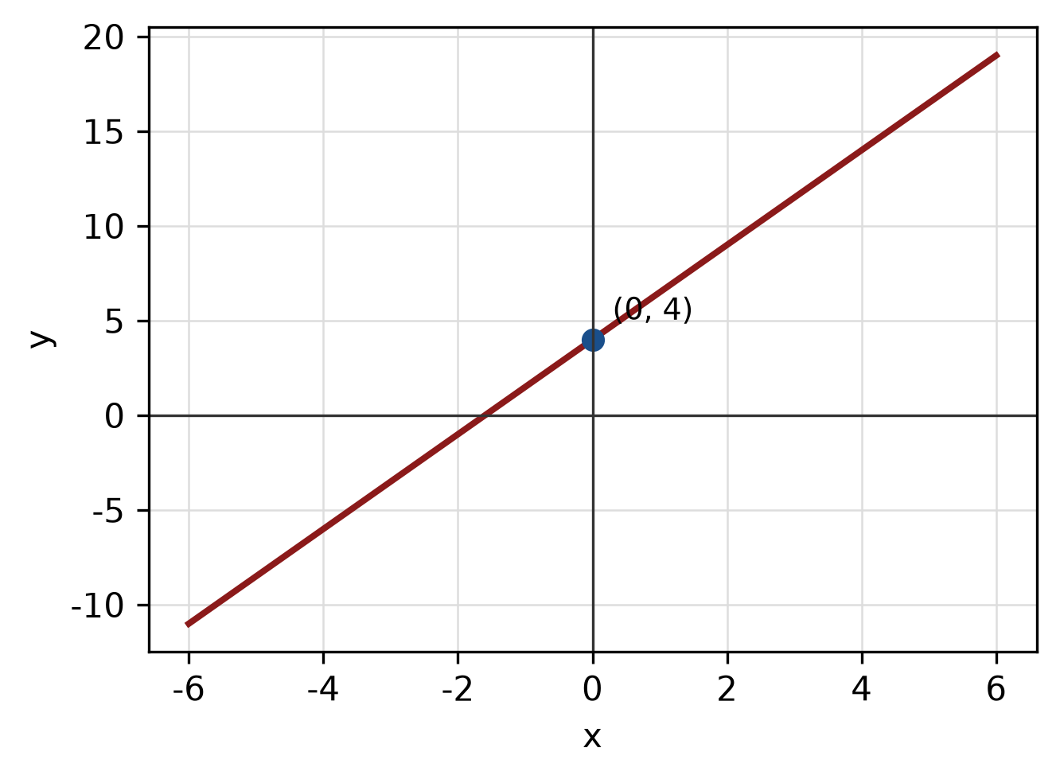
Figure: required line.
QUESTION 5
a) Given sin A = 8/17 where A is in quadrant II and cos B = 15/17 where B is in quadrant IV, find sin 2A and cos(A + B).
(5 marks)
b) Convert 90° to radians, and convert π/6 radians to degrees.
(3 marks)
c) Solve the triangle with sides a = 14 cm, b = 48 cm and c = 50 cm. Find all three angles.
(5 marks)
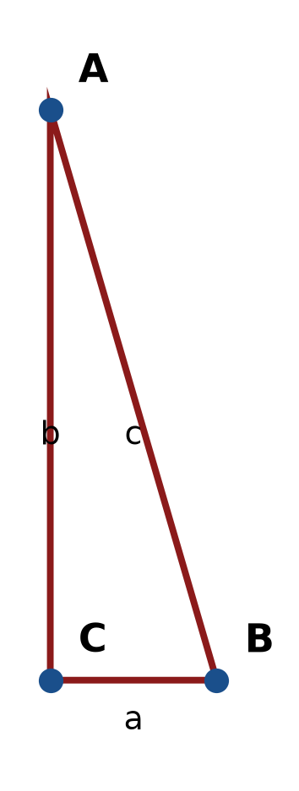
Figure: right triangle.
END OF QUESTION PAPER

APPENDIX 1
Formula sheet (as supplied with the paper).
sin² A + cos² A = 1 | tan² A + 1 = sec² A
sin(A + B) = sin A cos B + cos A sin B | tan 2A = 2 tan A / (1 − tan² A)
cos(A + B) = cos A cos B − sin A sin B | Arc length, s = rθ
tan(A − B) = (tan A − tan B) / (1 + tan A tan B) | Area of sector = ½r²θ
cos 2A = cos² A − sin² A | a / sin A = b / sin B = c / sin C
cos 2A = 1 − 2sin² A = 2cos² A − 1 | a² = b² + c² − 2bc cos A
sin 2A = 2 sin A cos A | Area of triangle = ½ab sin C

